Practicum Case | 
COMP6885 | COMP6885001
Natural Language Processing
Computer Science | O251-COMP6885-JD01-04
Valid on Odd Semester Year 2024/2025 | Revision 00

Learning Outcomes
- LO1 - describe what is Natural Language Processing and its components
- LO2 - explain Explain fundamental concepts of how to work with Natural Language Processing

Topic
- Session 04 – TF-IDF and Cosine Similarity

Sub Topics
- TF-IDF
- Cosine Similarity

Soal
Case
Learning TF-IDF and Cosine Similarity

You have a senior programmer that taught you how to use TF-IDF and Cosine Similarity. Your task is to review the process by doing this step:
- First you will use this two sentences in your code:
document1 = 'Alice was beginning to get very tired of sitting by her sister on the bank, and of having nothing to do: once or twice she had peeped into the book her sister was reading, but it had no pictures or conversations in it, and what is the use of a book thought Alice without pictures or conversations'
document2 = 'Alice was beginning to get very tired of sitting by her sister on the bank, they thinking of going home and then playing together'

- Get all the words from each sentence and remove all stopwords.
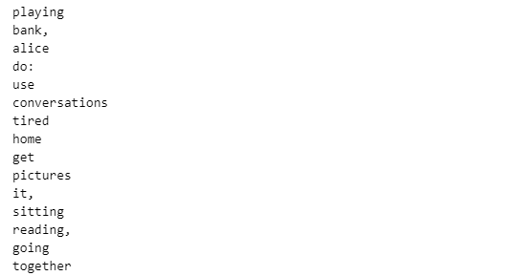
Figure 1. filtered words

- Calculate each word’s TF-IDF manually.
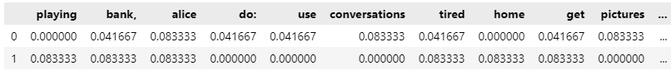
Figure 2. Result Compute TF manually
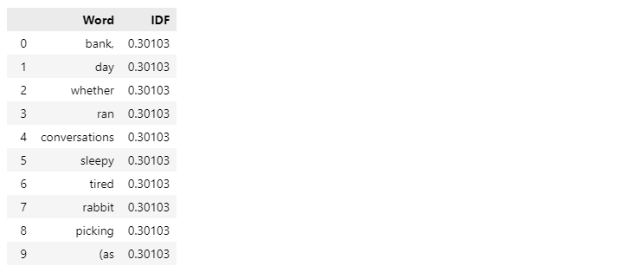
Figure 3. Result Compute IDF manually
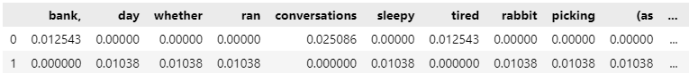
Figure 4. Result Compute TF-IDF manually
- Then try to calculate TF-IDF using TfidfVectorizer and show the cosine similarity.
